Specification

Rework of gallery

Rhys Gillham

2022

Table of Contents

Requirements 2

Tech Stack 2

Front End 2

Back End 2

Front End Design 3

Navigation Design 3

Home Page 3

Company Page 3

Console Page 4

Video Game Page 4

Back End Design 5

Database 5

Folder Structure 6

Models 6

Refactor or Extension Projects 7

General Refactoring 7

Front End 7

Framework Refactoring 7

Back End 7

API Creation 7

# Requirements

## Tech Stack

* Front end will be HTML, CSS, PHP, JavaScript, and Bootstrap
* Back end will be JavaScript and Node.js
* Database will by MySQL
* An API may be built for this service using asp.net or Node.js however it is not required at this time

## Front End

The front end of the website will have the following:

* A shared navigation banner that is accessible from all pages
* A log in ability to allow an admin to perform CRUD on entries
* A page for information about the project and contact information
* A page for companies
* A page for platforms
* A page for video games
* A page for peripherals
* The ability to view all information without requiring log in
* The ability to search and sort each page for select information
* All elements are sized based on REM

## Back End

The back end of the website will have the following:

* A database with normalised tables
* The ability to have 2 layers of control, one being a standard reader and the other being an admin
* Will access image data from a folder that has the path stored within the database via a relative path

# Front End Design

## Navigation Design

Lorem ipsum dolor sit amet, consectetuer adipiscing elit. Maecenas porttitor congue massa. Fusce posuere, magna sed pulvinar ultricies, purus lectus malesuada libero, sit amet commodo magna eros quis urna.

Nunc viverra imperdiet enim. Fusce est. Vivamus a tellus.

Pellentesque habitant morbi tristique senectus et netus et malesuada fames ac turpis egestas. Proin pharetra nonummy pede. Mauris et orci.

Aenean nec lorem. In porttitor. Donec laoreet nonummy augue.

Suspendisse dui purus, scelerisque at, vulputate vitae, pretium mattis, nunc. Mauris eget neque at sem venenatis eleifend. Ut nonummy.

## Home Page

Lorem ipsum dolor sit amet, consectetuer adipiscing elit. Maecenas porttitor congue massa. Fusce posuere, magna sed pulvinar ultricies, purus lectus malesuada libero, sit amet commodo magna eros quis urna.

Nunc viverra imperdiet enim. Fusce est. Vivamus a tellus.

Pellentesque habitant morbi tristique senectus et netus et malesuada fames ac turpis egestas. Proin pharetra nonummy pede. Mauris et orci.

Aenean nec lorem. In porttitor. Donec laoreet nonummy augue.

Suspendisse dui purus, scelerisque at, vulputate vitae, pretium mattis, nunc. Mauris eget neque at sem venenatis eleifend. Ut nonummy.

## Company Page

Lorem ipsum dolor sit amet, consectetuer adipiscing elit. Maecenas porttitor congue massa. Fusce posuere, magna sed pulvinar ultricies, purus lectus malesuada libero, sit amet commodo magna eros quis urna.

Nunc viverra imperdiet enim. Fusce est. Vivamus a tellus.

Pellentesque habitant morbi tristique senectus et netus et malesuada fames ac turpis egestas. Proin pharetra nonummy pede. Mauris et orci.

Aenean nec lorem. In porttitor. Donec laoreet nonummy augue.

Suspendisse dui purus, scelerisque at, vulputate vitae, pretium mattis, nunc. Mauris eget neque at sem venenatis eleifend. Ut nonummy.

## Console Page

Lorem ipsum dolor sit amet, consectetuer adipiscing elit. Maecenas porttitor congue massa. Fusce posuere, magna sed pulvinar ultricies, purus lectus malesuada libero, sit amet commodo magna eros quis urna.

Nunc viverra imperdiet enim. Fusce est. Vivamus a tellus.

Pellentesque habitant morbi tristique senectus et netus et malesuada fames ac turpis egestas. Proin pharetra nonummy pede. Mauris et orci.

Aenean nec lorem. In porttitor. Donec laoreet nonummy augue.

Suspendisse dui purus, scelerisque at, vulputate vitae, pretium mattis, nunc. Mauris eget neque at sem venenatis eleifend. Ut nonummy.

## Video Game Page

Lorem ipsum dolor sit amet, consectetuer adipiscing elit. Maecenas porttitor congue massa. Fusce posuere, magna sed pulvinar ultricies, purus lectus malesuada libero, sit amet commodo magna eros quis urna.

Nunc viverra imperdiet enim. Fusce est. Vivamus a tellus.

Pellentesque habitant morbi tristique senectus et netus et malesuada fames ac turpis egestas. Proin pharetra nonummy pede. Mauris et orci.

Aenean nec lorem. In porttitor. Donec laoreet nonummy augue.

Suspendisse dui purus, scelerisque at, vulputate vitae, pretium mattis, nunc. Mauris eget neque at sem venenatis eleifend. Ut nonummy.

# Back End Design

## Database

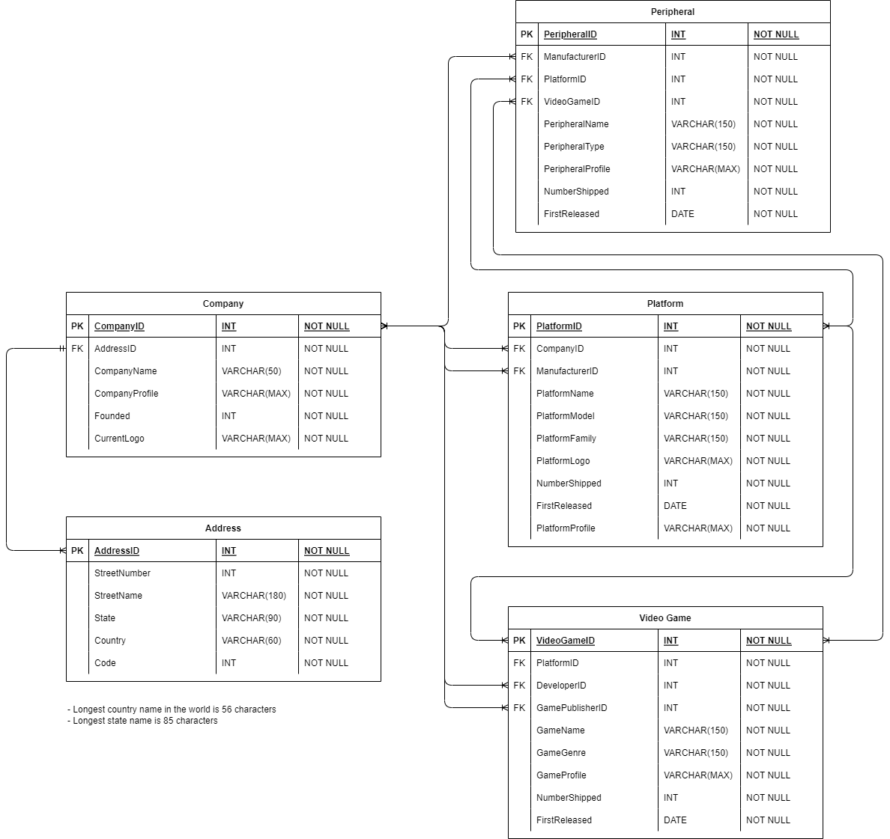

The above diagram shows the overall view of the database, as the industry is spread out over multple companies for both development, manufacturing, and distribution almost all of the relationships are one to many. The exception to this is an address can only belong to a single company, this may not prove true in all situations however and may need to be revised as a more complete collection of information is made available.

## Folder Structure

The folder structure is set out below, it is intended to store files in logical locations and allow for quick navigation to the areas that are intended to be worked in.

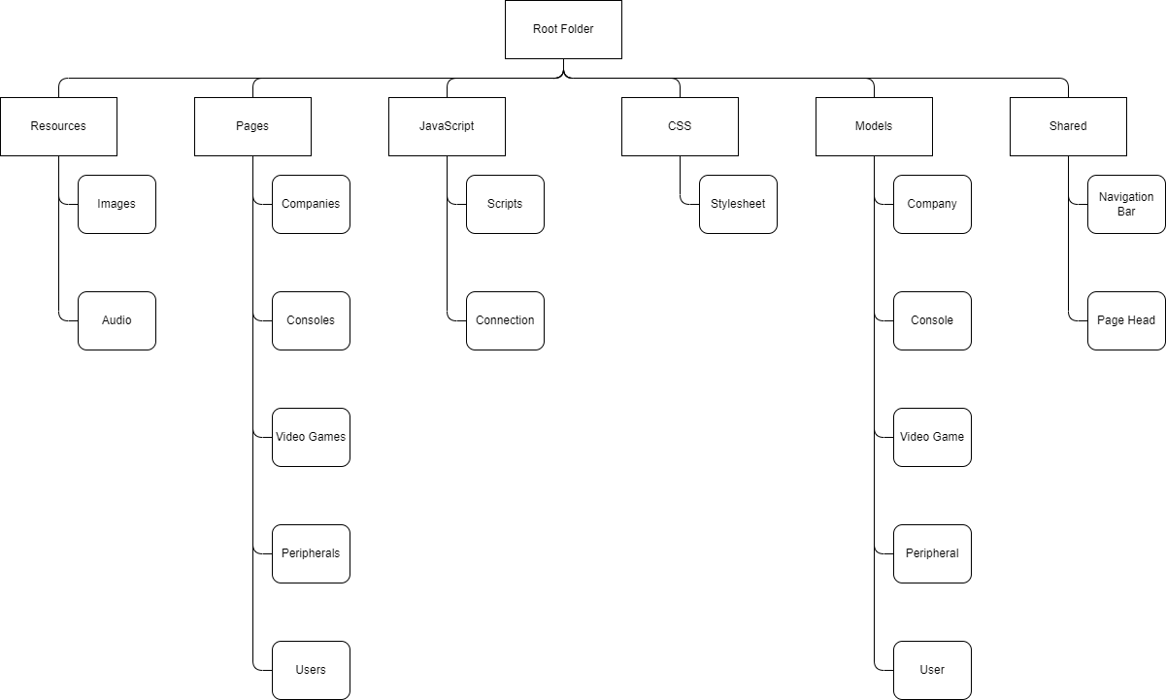

Figure Folder structure for the website

## Models

There will be models generated to represent the objects on the page, this will include:

* A model for a video game
* A model for a console
* A model for a peripheral
* A model for a user
* A model for a page that contain more than one of the above models

# Refactor or Extension Projects

### General Refactoring

It is anticipated that there will be several things learned over the course of the project and refactoring and cleaning up of the website will be required. This may include using methods which are more fit for purpose that were generated later in development or creating a new file to facilitate more explicit concepts to make further changes cleaner and more flexible.

## Front End

The front end of this website will be running with vanilla languages and be a good candidate for further design decisions to be made.

### Framework Refactoring

Once complete the front end will be functioning with vanilla JavaScript and it would be a good candidate for refactoring into a popular framework such as React, Angular, or Vue.js. The team will be consulted regarding this, and the framework will be determined at that time.

## Back End

The back end of this website will be directly connecting and interacting with the database and will be a good candidate for further design decisions to be made.

### API Creation

Directly interfacing with the database is sufficient for this website however if PC or phone applications are going to be created for other language practice there is a strong case for the creation of an API that can facilitate this. Doing so will also allow for a central repository of information to draw on for other projects with a stream of information that is valid, and models are known and well understood.